Page Content:

CoVitality Survey Communication to Parents/Guardians

High Tech High is dedicated to educating the whole child, which includes promoting social and emotional development. This academic school year (2021-2022), all of the students at High Tech Middle North County will be participating in a brief survey to help measure social and emotional strengths and challenges. All students who agree to participate will complete a brief 10-15 minute survey during advisory class during Winter of 2021.

Determining students’ social and emotional strengths and challenges will help our staff better understand our students, what type of support they may need, as well as give us insight into the strengths that help them succeed and flourish in life. This is especially important now during the pandemic and post distance learning. The pandemic may have caused stress and uncertainty in our children, but it may have also highlighted their resilience. This survey will help us identify your child’s resilience factors and areas we can focus on developing further. Student participation in the survey is voluntary and opting out will not impact your child’s academic status or access to any services.

Frequently Asked Questions:
Q. What is CoVitality?

A: CoVitality is the world’s most researched validated and empirically supported Social Emotional Learning screener. The CoVitality framework is a complete mental health screening tool that schools use to measure the social emotional well-being of ALL their students - not just those who already have identified challenges. CoVitality uses the Social Emotional Health Survey - Secondary (SEHS-S) that is evidence-based and highlights BOTH the strengths and weaknesses of a child’s mental wellbeing. This assessment tool is used to measure key positive psychological attributes associated with students’ positive, thriving development.

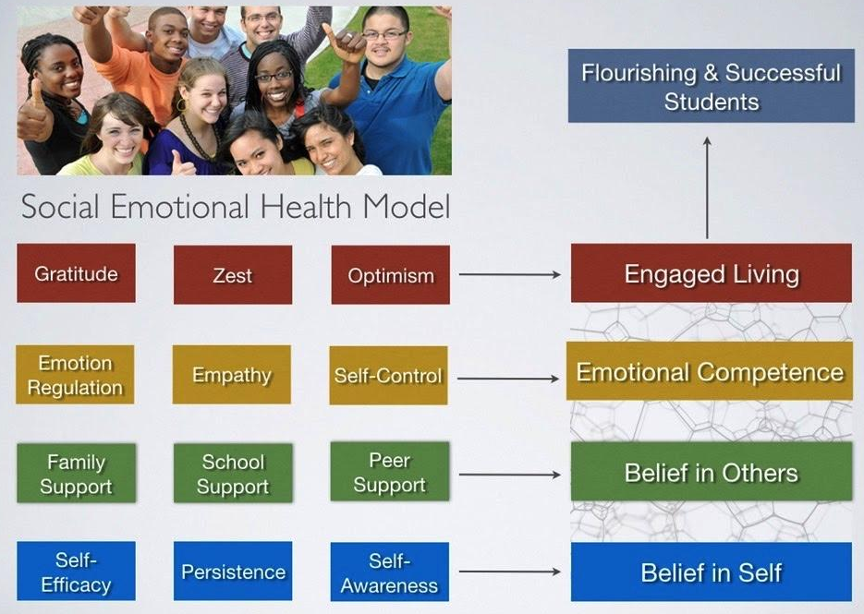

One of the main benefits of CoVitality is that educators can shift away from the typical “wait to fail” or “teacher referral” system that schools use to currently address student mental health. It also offers us an opportunity to start looking at PREVENTING failing students first, so we can lessen the teacher referrals in the long run. This most importantly results in more thriving students.

If you’d like to learn more about Project CoVitality please visit https://www.covitalityucsb.info/

Q. Does my child’s participation in this survey provide information about any suspected mental health issues?

A: No, the survey screens for positive psychological attributes (e.g. gratitude, empathy, peer support, persistence, etc) as a means to highlight resiliency factors and overall positive wellbeing.

Q. I do not want my child to participate in this screener, who should I contact?

A: If you do NOT want your child to complete this survey, please alert your child’s advisory teacher that you’d like to opt them out of this survey via email or phone call. Note: Your child may withdraw participation at any time.

Q. Does the screener allow for parent input?

A: Currently, the screener is administered via student self report and does not allow for parent
input at this time.

Q. Who has access to student data, how is it stored?

A: The survey is hosted and results are gathered through the tool. The CoVitality team (Vendor) has access to monitor and check in on progress, as well as for user support troubleshooting (not individual student data). All the data that is seamlessly transferred into the App is protected using industry standard encryption and follows standard HIPPA and FERPA security protocols to ensure confidentiality. The student specific information is not shared with an outside entity.

The survey results come in via real time allowing members of the Mental Health Team (director, dean, school psychologist) who have password-protected log-ins to the app to view the student data and generate reports.

Q. How will the data be used?
A: CoVitality data is used in a variety of ways by schools and districts to support their students mental wellbeing and overall psychological health. Depending on the unique needs for your student population and existing support systems in place, there are many options for using results provided from your CoVitality screening to follow-up with students and empower your school’s wellness teams to take a data driven approach in support of your children.

Examples:
- Targeted Interventions
- Assessing School Climate
- Wellness & Prevention
- Professional Development for Teachers/Staff

