ECO APPLICATION FORM (2021-22)

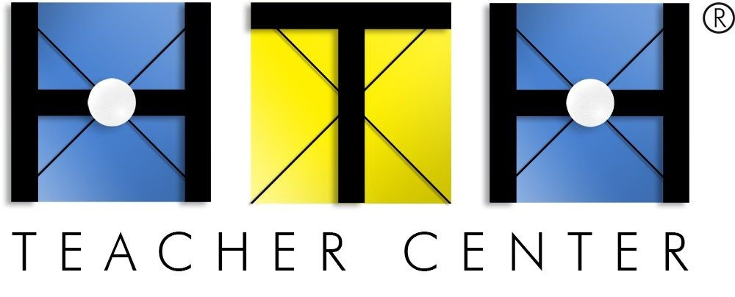
for Early Completion Option in the High Tech High Induction Program

Early Completion Option (ECO) is an OPTIONAL route that allows experienced teachers to complete Induction in one-year based on 2+ years of full-time successful teaching experience. ECO applications will be reviewed and granted to teachers that meet either of the criteria listed below.

- TO BE COMPLETED BY Applicant:

Name (first and last):
Personal Email:
Phone #:

​(Initial)​ I understand that the ECO option is available to experienced and exceptional teachers who meet ​either​ of the eligibility criteria listed below (​check one​):

I completed the HTH District Intern program (graduation date):
Note: HTH District Intern completers do not need to complete Section 2 of this form.
OR
I have 2+ years of prior full-time teaching experience as verified in Section 2 below (required).

2. EMPLOYMENT HISTORY VERIFICATION:

I certify the above listed individual was employed full-time as a Teacher of Record:

Employer # 1 |  | Employer # 2 (if needed)
School & District: |  | School & District:
Start Date: |  | Start Date:
End Date: |  | End Date:
% FTE |  | % FTE
Grade & Subject: |  | Grade & Subject:
Administrator Name: |  | Administrator Name:
Administrator Email: |  | Administrator Email:
Signature & Date: |  | Signature & Date:

Applicant: Please Upload completed form with your Induction Application.
High Tech High Teacher Center | 2150 Cushing Road | San Diego, CA 92106 www.hightechhigh.org/teachercenter | CTC Accredited to Prepare California K-12 Teachers

