EMPLOYMENT VERIFICATION FORM (2021-22)
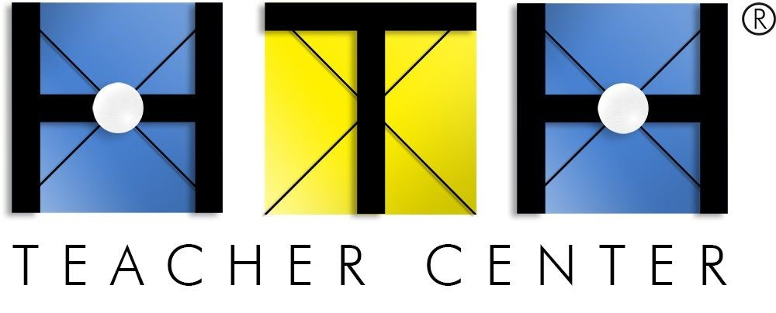
for admission to enroll in the High Tech High Induction Program

Induction is a professional development program designed to support newly-credentialed teachers. The High Tech High (HTH) Induction program incorporates improvement science and collegial coaching and is aligned with the California Standards for the Teaching Profession (CSTP). Upon completion of the two-year program, or one-year Early Completion Option (ECO), teachers earn their California Clear Credential.

TO BE COMPLETED BY APPLICANT: Please select Credential Type

Multiple Subject Credential Single Subject Credential Education Specialist Credential
Name (first and last):
Street Address:
City, State, Zip:
Phone #:
Personal Email:

(Initial)​ I understand official enrollment into the HTH Teacher Induction program is contingent upon: a) hold a CA Preliminary Teaching Credential in one of the following areas: Single Subject, Multiple Subjects, or Education Specialist Mild/Moderate Disabilities and b) employment as the teacher of record in a teaching assignment that matches the credential being pursued.

TO BE COMPLETED BY EMPLOYER:

School & District:
Teaching Assignment (subject):
Teaching Grade(s):
% FTE:
Administrator Email:
Name & Title of Administrator:

(Initial)​ ​I certify the above listed individual is or will be employed at least 50% as the Teacher of Record at a K-12 public school for the ​2021-22​ school year.

Administrator Signature Date

Applicant: Please Upload completed form with your Induction Application.
High Tech High Teacher Center | 2150 Cushing Road | San Diego, CA 92106 www.hightechhigh.org/teachercenter | CTC Accredited to Prepare California K-12 Teachers

